SAVE COMP
Collection and development of best practices in cross border cases for the survival of distressed companies
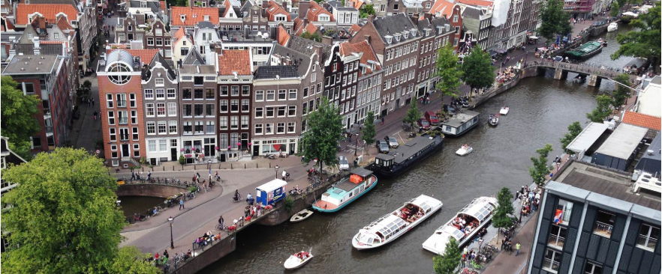

Following a practical comparative international methodology, the goal of the Project is to collect and exchange best practices in the field of insolvency and pre-insolvency cross-border proceedings, so to help office holders in insolvency proceedings to better coordinate and implement international cooperation, thus enhancing management of multiple proceedings, reoganisation of companies and the protection of creditors and interests of stakeholders.
The Project aims at collecting best practices, rules of PIL and case law in insolvency and pre-insolvency cross-border proceedings at the domestic level, so to disseminate these first results. Moreover, the Project aims to compare the domestic best practices (either already followed in the MSs involved in the research, or suggested by the Partners) so as to possibly develop and exchange best practices which might be of use in cross-border proceedings.
The Project, to identify areas of insolvency and pre-insolvency cross-border proceedings where best practices could enhance the possibility to save distressed companies, enhance protection of cross-border creditors and stakeholders, foresees the involvement of practitioners to help identify problematic issues and already developed best practices, called to answer a practitioner questionnaires, and participate to the local and final conferences.
The collected case law and legislation will be available on the database unalex, and will be freely accessible.

DURATION
2016-2018

PROJECT PARTNERS
Università degli Studi di Genova (Applicant)
Ilaria Queirolo
Laura Carpaneto
Maria Elena De Maestri
Francesco Pesce
Stefano Dominelli
Universitat de Valencia (Co-Beneficiary)
Carlos Esplugues Mota
Guillermo Palao Moreno
Francisco Gomez Fonseca
University of Amsterdam (Co-Beneficiary)
Aukje van Hoek
Arthur Salomons
Institute of Private International Law, Sofia (Co-Beneficiary)
Nikolay Natov
Boriana Mousseva
Biznesa augstskola Turība (Co-Beneficiary)
Dana Rone
Ieva Broka
Kristīne Tihanova
IPR Verlag (Co-Beneficiary)
Thomas Simons
Sibylle Calabresi-Scholz
University of Glasgow (Associate Partner)
Janeen Carruthers
Charles University in Prague (Associate Partner)
Monika Pauknerova
Magdalena Pfeiffer
Jan Brodec
Johannes Gutenberg Universität Mainz
Urs Peter Gruber
Ivo Bach

DISPO PARTICIPANTS
Ilaria QUEIROLO, Laura CARPANETO

KEY WORDS
European Union Law, judicial cooperation in civil matters, insolvency

FUNDINGS
European Commission, JUST/2014/JCOO/AG/CIVI/7693

